ID – hrajranj
Day 22 - 30th july 2025

Task 1:

What is good code vs Bad code ..
Good code is like a well-built bridge—strong, elegant, and easy to maintain:
- Readable: Easy to understand at a glance. Clear variable names, consistent formatting, and logical flow.
- Modular: Broken into reusable, single-responsibility methods or classes.
- Efficient: Doesn't waste resources—no redundant loops or unnecessary computations.
- Scalable: Adapts easily to new features or increased data.
- Well-documented: Includes concise comments and external documentation when needed.
- Follows design principles: Like the Open/Closed Principle you’ve been exploring—code should be open for extension, closed for modification.
Bad code is like a tangled earphone cable—hard to use, harder to fix:
- Hard to read: Cryptic names like temp1, inconsistent indentation, or spaghetti logic.
- Poor structure: Everything packed into one massive method or class.
- Inefficient: Slow algorithms, duplicate logic, excessive resource use.
- Fragile: Breaking one part causes a cascade of failures elsewhere.
- Undocumented: No comments or clarity—other devs (or your future self!) will be lost.
- Violates principles: Tightly coupled, overdependent code that resists change.

Task 2:

BAD CODE vs GOOD CODE - ORAL

Task 3:

What do you understand by databinding?
Data Binding is a powerful programming concept that connects your UI (user interface) elements directly to your data sources—so when the data changes, the UI updates automatically, and vice versa.
🛠️ Types of Data Binding
- One-way binding: Data flows from the source (like a variable) to the UI. Example: showing a user's name in a TextView.
- Two-way binding: Data flows both ways—if the user edits the UI, the underlying data updates too. Example: typing in a form updates the model.
Benefits
- Reduces boilerplate code
- Improves performance
- Makes code cleaner and easier to maintain
- Supports MVVM architecture

Task 4:

What do you know about continuous development
Continuous Development is a modern software approach where updates, improvements, and fixes are released in small, frequent batches—rather than waiting for big, infrequent releases.
Continuous development is an umbrella term that includes:
- Continuous Integration (CI): Developers frequently merge code into a shared repository, triggering automated builds and tests.
- Continuous Delivery (CD): Code is always in a deployable state, ready to be released at any time.
- Continuous Deployment: Every change that passes automated tests is automatically pushed to production.
- Continuous Testing: Automated tests run frequently to catch bugs early.
Why It Matters
- Faster Feedback: Developers get instant insights into how their changes affect the system.
- Higher Quality: Frequent testing and integration reduce bugs and improve reliability.
- Lower Risk: Small updates are easier to validate and roll back if needed.
- Improved Productivity: Automation frees up developers to focus on building features.
- Better User Experience: Users get new features and fixes faster2.
Tools & Practices
- CI/CD Pipelines: Jenkins, GitLab CI, CircleCI, etc.
- Version Control: Git-based workflows
- Automation: Build, test, and deployment scripts
- Quality Gates: Enforce standards before code is merged or released
📦 Real-World Example
Imagine you're building a mobile app. Instead of waiting months to release a major update, you push weekly improvements—like bug fixes, UI tweaks, or new features. Users stay engaged, and your team avoids the stress of massive releases.

Task 5:

What are the conditions for polymorphism?
Polymorphism is like giving your code the ability to wear different hats depending on the situation 🎩—same interface, different behavior. In Java (and most OOP languages), polymorphism comes in two main flavors: compile-time and runtime, and each has its own set of conditions.
🧪 Conditions for Compile-Time Polymorphism (Static)
Achieved via method overloading:
- Methods must have the same name but different parameter lists
  - Different number of parameters
  - Different types of parameters
  - Different order of parameters
- Must be defined within the same class
- Resolved by the compiler at compile time
🔄 Conditions for Runtime Polymorphism (Dynamic)
Achieved via method overriding:
- A subclass must override a method from its superclass
- Method must have the same name, return type, and parameters
- The superclass reference must point to the subclass object
- Resolved by the JVM at runtime
✅ General Conditions for Polymorphism
- Inheritance: There must be a parent-child relationship
- Method Signature Rules: Overloading requires variation; overriding requires exact match
- Access Modifiers: Overridden methods must not be more restrictive than the original
- Non-static Methods: Only instance methods can be overridden (not static ones)
Task 6:

import org.junit.jupiter.api.Test;
import static org.junit.Assert.assertEquals;
public class JunitTest01 {
String message = "hello All How are you";
@Test
void testMsg() {
System.out.println("asserting the Test case ");
assertEquals("hello All How are you", message);
}
}
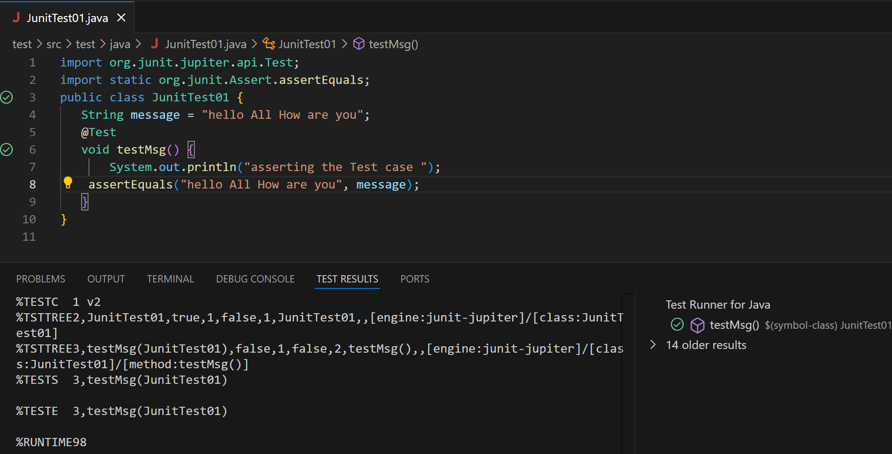
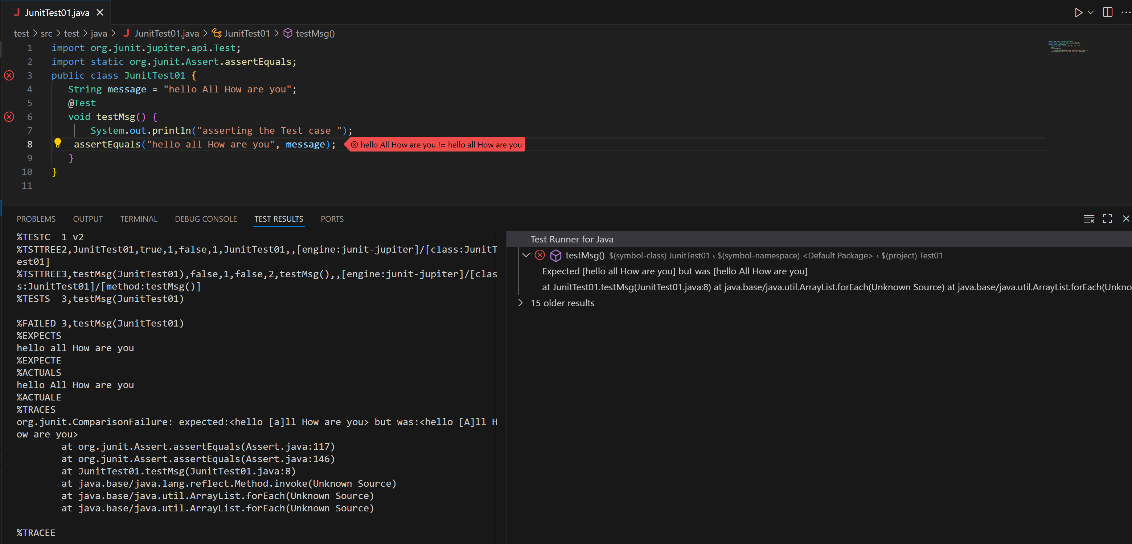

Task 7:

import org.junit.jupiter.api.Test;
import org.junit.jupiter.api.Tags;
import org.junit.jupiter.api.Assertions.assertEquals;
class TestCase02 {
@Test
@Tags("firstPriority")
void testMethod01() {

}

@Test
@Tag("firstPriority")
void runTestcase02() {

}
@Tags("fastTag")
void testMethod03() {

}

@Test
@Tag("slowTag")
void runTestcase04() {

}
}
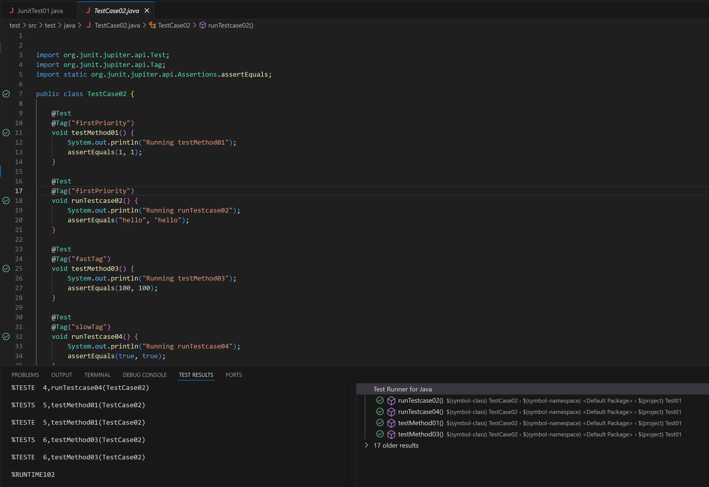

Task 08:

Write a test case for the below java file

public class Junit4Test {
public int compare(int n1, int n2) {
if (n1 > n2) return 1;
return -1;
}
}

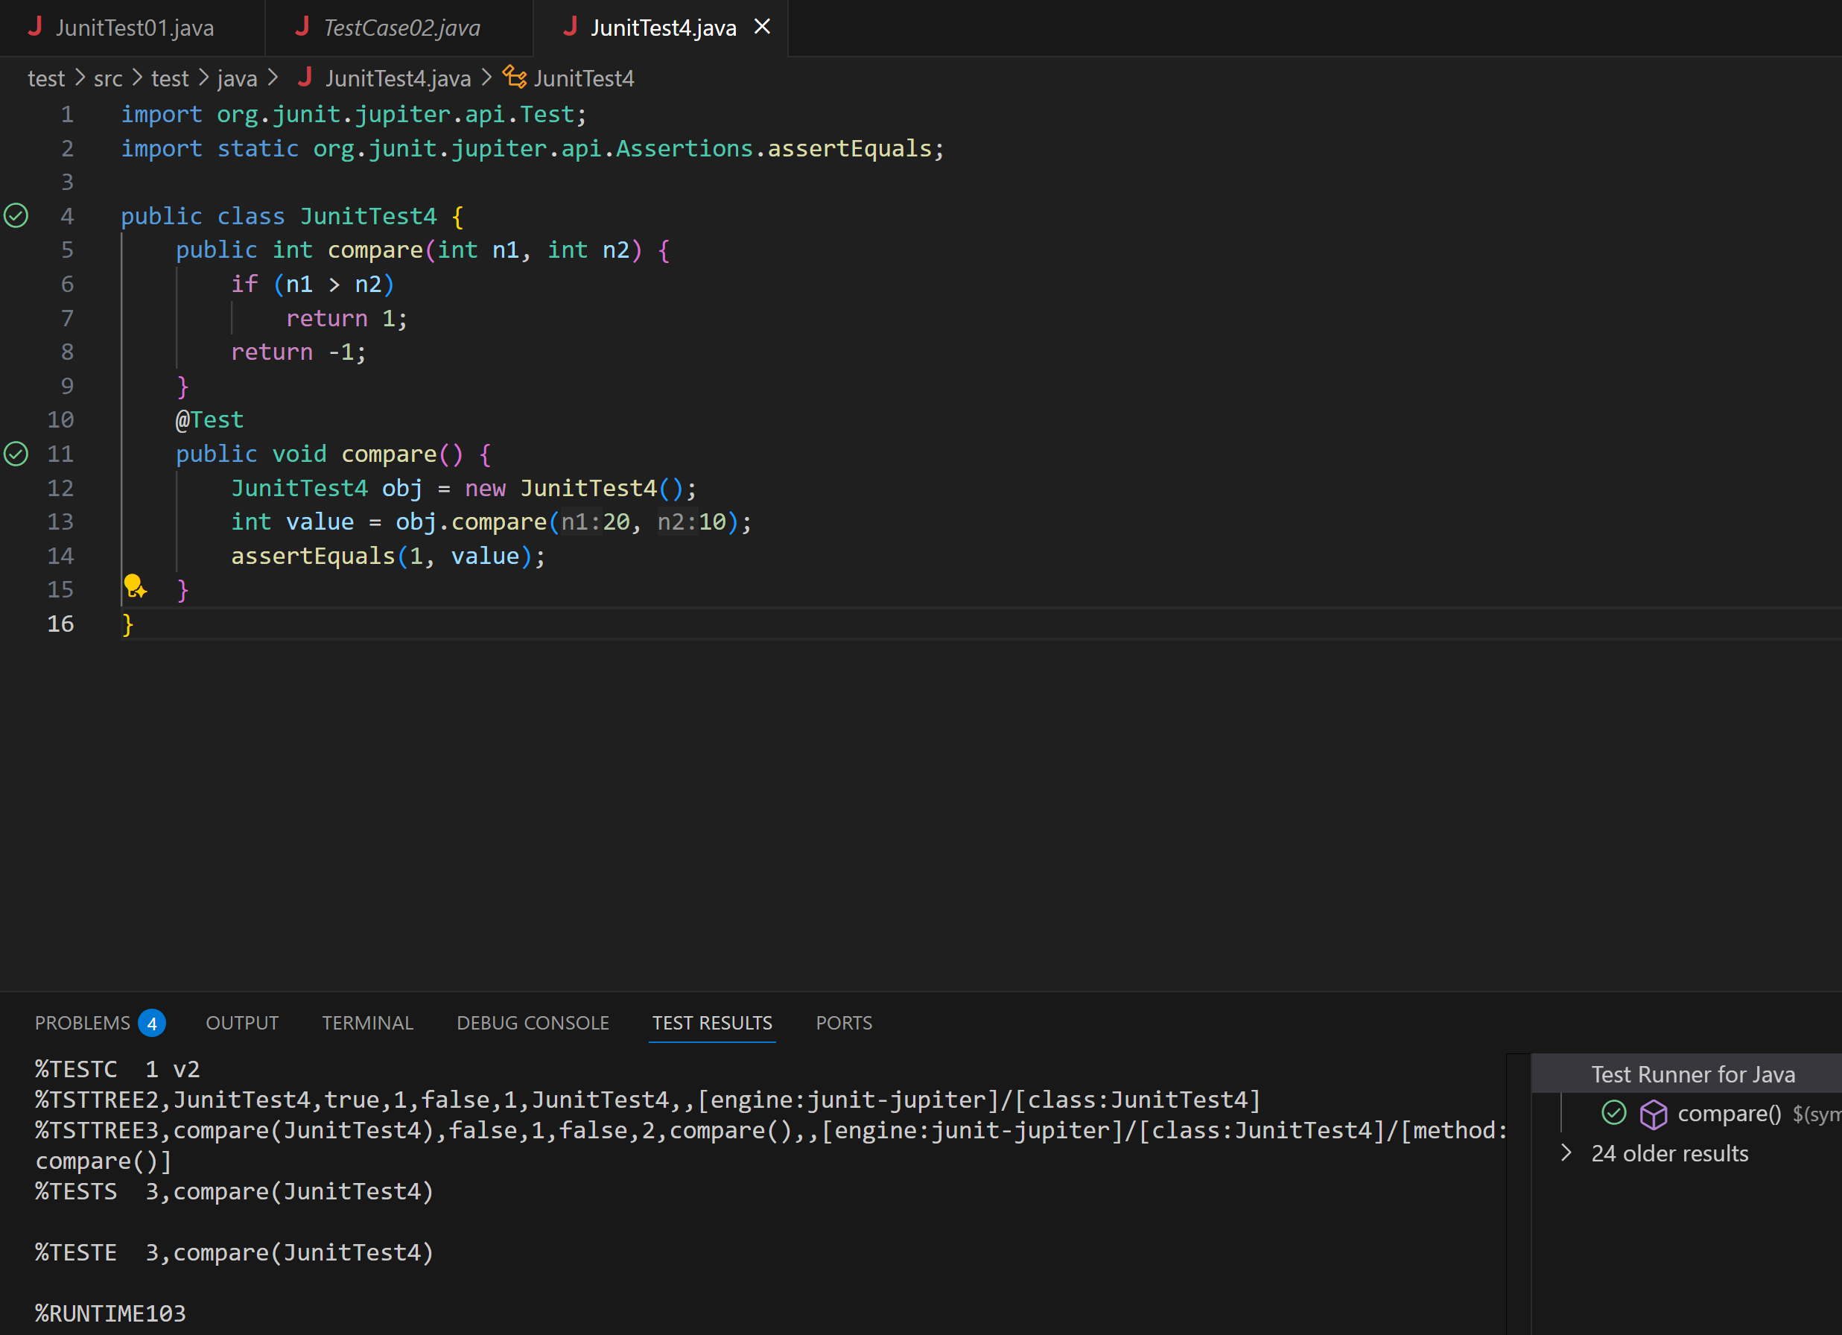

Task 09:
Write test case for below code
public int compare(int n1, int n2) {
if (n1 > n2) return 1;
else if (n1 < n2) return -1;
return 0;
}
